

AI - LAB 05

Submitted To: Rasikh Ali
Submitted By: Mian Abdullah
Roll No: 024
Section: BSSE-4A
Subject: AI ( LAB )

Art Tree
Diagram of tree:
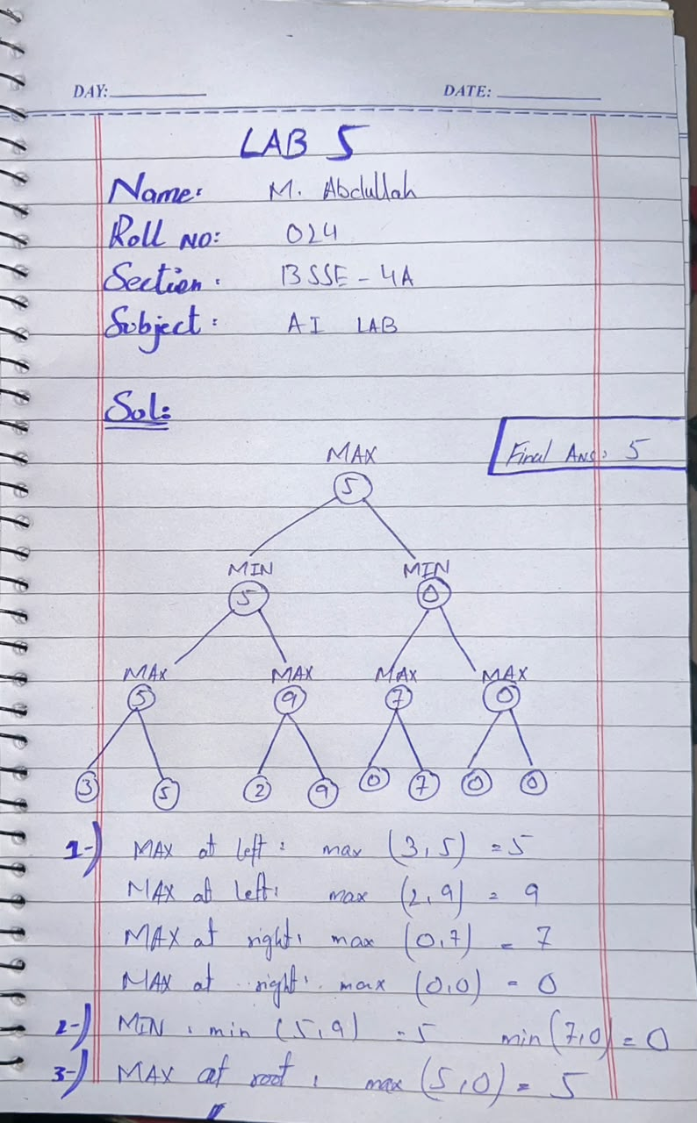

Explanation of this tree:
Leve 1: Leaf Nodes:
Original Values:
(3, 5, 2, 9, 0, 7, 0, 0)

Level 2: MAX:
Calculation | Assigned Value
MAX(3, 5) | 5
MAX(2, 9) | 9
MAX(0, 7) | 7
MAX(0, 0) | 0

Level 3: MIN:
Calculation | Assigned Value
MIN(5, 9) | 5
MIN(7, 0) | 0

Level 4: Root MAX:
MAX(5, 0) = 5

